Impact of Digital Nomadism: Challenges and Opportunities

**Submitted by:**

|  |  |  |
| --- | --- | --- |
|  | Parul Kumar | 102103323 |
|  | Ishayu Jadon | 102103336 |
|  | Shaurya Goel | 102103339 |
|  | Armaan Khera | 102103341 |

**HUMANITIES TECHNICAL REPORT**

Impact of Digital Nomadism: Challenges and Opportunities

**(UHU005)**

**Humanities for Engineers**

**Submitted by:**

|  |  |
| --- | --- |
| Parul Kumar | 102103323 |
| Ishayu Jadon | 102103336 |
| Shaurya Goel | 102103339 |
| Armaan Khera | 102103341 |

**Submitted to: Mr. Kanish Jain**



# School of Humanities and Social Sciences Thapar Institute of Engineering and Technology November, 2024

**COPYRIGHT NOTICE**

©Copyright 2024 by Thapar Institute of Engineering & Technology. All rights reserved. This material may not be duplicated for any profit-driven approach.

The reports contained in these Internet-accessible directories are included by the contributing authors as a mechanism to ensure timely dissemination of scholarly and technical information on a non-commercial basis. Copyright and all rights therein are maintained by the authors, despite their having offered this information electronically. Everyone copying this information must adhere to the terms and constraints invoked by each author's copyright.

Reports may not be copied for commercial redistribution, republication, or dissemination without the explicit permission of the School of School of Humanities & Social Sciences at Thapar Institute of Engineering & Technology, Patiala and the authors.

# LETTER OF TRANSMITTAL

Date: 14thNovember, 2024 Respected Sir,

This is to inform you that we have prepared a report on the topic “Impact of Digital Nomadism: Challenges and Opportunities” and now we are submitting the same to you.

This report examines the phenomenon of digital nomadism, focusing on the challenges and opportunities it presents for individuals and economies alike. We explore how this lifestyle affects work-life balance, mental health, and productivity, as well as its implications. Through qualitative analysis and a general survey, we aim to illuminate the public perception related to this phenomenon. The rise of digital nomadism has transformed the way people approach work and travel, which prompted us to investigate its multifaceted impact and share our insights in this report.

|  |  |
| --- | --- |
| Yours Sincerely, |  |
| Parul Kumar | 102103323 |
| Ishayu Jadon | 102103336 |
| Shaurya Goel | 102103339 |
| Armaan Khera | 102103341 |

# CERTIFICATE

This is to certify that the report titled “Impact of Digital Nomadism: Challenges and Opportunities” embodies the original work done by students of Thapar Institute of Engineering and Technology, Batch 4CO12.

|  |  |
| --- | --- |
| Parul Kumar | 102103323 |
| Ishayu Jadon | 102103336 |
| Shaurya Goel | 102103339 |
| Armaan Khera | 102103341 |

Under the Supervision of **Mr. Kanish Jain**

Date: 14thNovember, 2024 Place: Patiala

# ACKNOWLEDGEMENTS

Firstly, we would like to express our profound veneration and deep sense of gratitude to our research supervisor Mr. Kanish Jain for making us capable and confident through her teachings and guidance in every aspect of life. We will always be indebted to her for her valuable contribution in making us understand our goals and clearing our perspective regarding the allotted work.

We are also grateful to all the faculty members in the Department. We are also thankful to the office staff for their cooperation. We are proud to be students of the department and grateful to be students of Thapar University, Patiala.

Above all, we would like to thank the Almighty for his blessings and our families and friends for their unending motivation.

# ABSTRACT

Digital Nomadism, as the name suggests, is a modern adaptation of traditional nomadic lifestyle blending mobility with digital work opportunities. This report is an analysis of the socio-economic and cultural impacts of digital nomadism on local communities and cities, exploring both the opportunities and the challenges this model serves.

Digital nomadism is driven by the global shift towards remote work, powered with technological advancements allowing individuals to work from various locations of the world. The presence of digital nomads brings economic benefits, like increased spending on housing, tax revenue through visas, local fees for services, tourism etc. Moreover, it also incentivizes the infrastructure improvements in areas like transport, internet connectivity, co-working spaces etc. Additionally, it facilitates cultural exchange between the workers and the local residents of the community promoting an entrepreneurship ecosystem. Interestingly, survey results indicate that a majority of respondents (83.1%) prefer a hybrid work model, valuing the flexibility to work both remotely and in-person. Although remote work has been largely effective, 60.6% believe it is situationally effective, suggesting a dependence on job roles and individual work styles. Moreover, remote work’s influence on local economies is viewed positively by 45% of respondents, though some are cautious about its impact on local businesses, as an influx of franchises could risk overshadowing locally owned shops.

Digital nomadism also introduces challenges, particularly concerning the housing market strain. The influx of remote workers has driven up housing costs, leading to gentrification and socio-cultural disparities. As focus increases on short-term investments, like rising demand for short-term rentals and temporary coworking spaces, they limit the economic benefits that the long-term residents bring in a community. Ironically, around 42% of our survey respondents who identify as remote workers also report facing increased living costs in popular digital nomad destinations. Another concerning issue. Additionally, in popular areas, the rise of brand stores and chains tends to displace or overshadow local shops, with more than 65% of survey respondents expressing concern about the impact of franchises on the local business landscape. Another notable challenge includes increased feelings of isolation among remote workers where the survey shows a whopping 83% of respondents expressing concerns about loneliness in remote work environments. Other notable concerns include cultural shifts like dilution of traditional roots and practices as communities adapt to cater to transient populations. These shifts can alter the local culture and sense of community, affecting both residents and digital nomads seeking authentic cultural experiences.

|  |  |
| --- | --- |
| **TABLE OF CONTENTS** | |
| Title Page | (i) |
| Copyright Notice | (ii) |
| Letter of Transmittal | (iii) |
| Certificate | (iv) |
| Acknowledgements | (v) |
| Abstract | (vi) |
| 1. Introduction | 1 |
| 2. Literature review | 3 |
| 3. Objectives | 9 |
| 4. Methodology | 11 |
| 5. Results and Discussion | 13 |
| 6. Conclusion | 19 |
| 7. Recommendations | 20 |
| References | 23 |
| Appendix | 24 |

# LIST OF ILLUSTRATIONS

|  |  |
| --- | --- |
| **Illustration** | **Page No.** |
| Fig. 5.1: Pie chart depicting the preferred work structure. | 13 |
| Fig. 5.2: Pie chart depicting the effectiveness of remote work. | 13 |
| Fig. 5.3: Bar graph depicting the productivity of work-life balance. | 14 |
| Fig. 5.4: Bar graph depicting the drawbacks of working from different locations. | 14 |
| Fig. 5.5: Pie chart depicting the concern about isolation. | 15 |
| Fig. 5.6: Pie chart depicting the local economy impact. | 15 |
| Fig. 5.7: Bar graph depicting the factors influencing choice of remote work. | 16 |
| Fig. 5.8: Pie chart depicting the impact on professional development. | 16 |
| Fig. 5.9: Bar graph depicting the impact of franchises on local businesses. | 17 |
| Fig. 5.10: Bar graph depicting the modernization of developing cities. | 17 |
| Fig. 5.11: Bar graph depicting the impact of chains and tourist shops. | 18 |

**INTRODUCTION**

Digital nomadism, a modern evolution of the traditional nomadic lifestyle, has become a transformative trend in the global workforce.

Traditionally, nomadism described communities or individuals who moved from place to place, often seasonally, in search of resources or opportunities. The early nomadic lifestyle was common among hunter-gatherers and pastoralists, and was deeply integrated into local economies as nomads traded goods and knowledge with various communities. Historically, nomadism has vastly influenced the global economy by promoting exchange across regions, spreading culture, and supporting a flow of resources and ideas. Over centuries, transient lifestyles fostered a global exchange network that laid a foundation for trade routes, commerce, cultural interactions and reciprocations. The traditional form of nomadism diminished as agricultural societies developed, leading to settled communities. Yet, its influence on economic factors and cross-cultural exchange remains a significant part of history.

With the rise of technology and electronic communication, a modern adaptation more widely known as “digital nomadism” has emerged. Rooted in the same spirit of movement and exploration as the early nomadic lifestyle but shaped by a technologically driven world. Digital nomadism refers to individuals who leverage digital tools and the internet to work remotely, maintaining a location-independent lifestyle that allows them to live and work in various parts of the world. Unlike traditional nomads who moved primarily for survival or economic trade, digital nomads are often motivated by the desire for personal freedom, career flexibility, and global exposure. The digital transformation has facilitated this lifestyle shift, enabling people to work from anywhere with internet access.

Digital nomadism is a product of the 21st-century technological landscape, driven by advancements in high-speed internet, communication platforms, and collaborative tools. Similar to traditional nomads, digital nomads continue to impact economies by contributing to local businesses, tourism, and real estate in their host locations. Their mobile lifestyle creates an economic ripple effect as they rent housing, utilize local services, and engage in cultural exchanges that stimulate local economies. Additionally, digital nomads share a similar sense of adaptability and resourcefulness as traditional nomads, but their reliance on digital connectivity distinguishes them. This connection to technology supports the “borderless” economy, encouraging the fluid exchange of knowledge, ideas, and capital across regions in ways that echo historical nomadic influences on global trade and cultural transmission.

Digital nomadism offers numerous opportunities, particularly in economic terms, by bolstering local economies through increased spending on services such as hospitality, dining, and co- working spaces. Studies indicate that cities welcoming digital nomads benefit from their consumer spending in local sectors, including health and wellness services and shared workspace providers, which cater to their lifestyle needs. Additionally, digital nomads contribute to local revenue through tourism-related taxes, visas, and other fees, offering a stable

income stream for host cities. This economic boost is particularly advantageous for small businesses, making these cities hubs of economic activity that draw further investment and promote international conferences and meetups. This influx not only diversifies the local economy but also enhances the city’s reputation, attracting global attention and establishing these areas as thriving economic centres. In addition to economic growth, digital nomads bring a wealth of cultural diversity that fosters cross-cultural interactions. Their presence promotes inclusivity and the exchange of ideas, enriching the social fabric of a city. This cultural blend facilitates collaborative ventures between digital nomads and local entrepreneurs, spurring innovation and enhancing the local business landscape. Furthermore, in response to the needs of digital nomads, many host cities invest in infrastructure improvements, such as enhanced internet connectivity, co-working spaces, and reliable public transportation. These developments not only benefit digital nomads but also improve the quality of life for local residents. This infrastructure serves as a foundation that can stimulate continued economic development and attract additional remote workers, ultimately providing lasting value to the host community.

However, the integration of digital nomads into host communities is not without challenges. The influx of high-earning transient residents often leads to increased demand for housing, driving up rents and contributing to gentrification. For example, short-term rental platforms catering to digital nomads have led to increased rents, ultimately displacing lower-income residents and widening the socioeconomic divide. The economic strain often extends beyond the housing market, as local businesses may shift their focus to serve the higher spending power of digital nomads, further marginalizing long-term residents. The rapid population shifts associated with digital nomadism also strain city infrastructure. Many cities face congestion in public transit systems, increased demand on energy resources, and challenges in waste disposal due to the influx of digital nomads. These pressures can impact the quality of life for permanent residents, who may experience decreased access to essential services as cities work to accommodate the demands of a transient, digitally connected population.

Similarly, social cohesion poses another complex issue, as the inherently transient nature of digital nomads complicates meaningful integration into local communities. The short-term stays typical of digital nomadism often limit community engagement, which can weaken the social fabric and creating a sense of cultural displacement for long-term residents. Locals may feel that their community’s identity is diluted as cities increasingly focus on accommodating international, transient populations. This cultural disconnection can lead to friction which can impact the continuity of traditional community structures and the cohesiveness of local culture. The tension between nomads and residents underscores the need for balanced policies that preserve the welfare of local populations while capitalizing on the opportunities digital nomadism presents.

# LITERATURE REVIEW

This literature review will examine the multifaceted impact of digital nomadism on host cities and communities, exploring both the opportunities and challenges it presents. Early discussions around remote work, particularly in the wake of the COVID-19 pandemic, often highlighted its positive aspects. However, as the trend evolves, it becomes crucial to consider the long-term effects, both positive and negative, of digital nomadism

# Opportunities Presented by Digital Nomadism -

## Economic Enhancement:

The advent of digital nomadism has significantly reshaped economic dynamics in host cities by driving higher levels of expenditure across multiple sectors. Blancas (2022) provides a comprehensive analysis illustrating that cities which actively embrace digital nomads reap notable economic advantages. This impact is most evident in the growth of the hospitality industry, food and beverage services, and the expansion of co-working facilities (Newland Chase). These sectors thrive due to the consistent and substantial spending habits of digital nomads, whose consumer behaviour bolsters the resilience of local economies and promotes diversified economic growth.

Furthermore, digital nomad hubs often evolve into epicenters of economic activity, attracting a broad spectrum of ancillary revenue opportunities. Morgan (2023) emphasizes that the strategic establishment of these hubs fosters a conducive environment for hosting international conferences, workshops, and entrepreneurial meetups (Global Citizen Solutions; Harvard International Review). These events not only stabilize income streams but also expand the economic landscape by drawing global attention and facilitating further investment. The influx of such professional gatherings enhances the city’s reputation as a vibrant economic center, creating a multiplier effect that benefits both service providers and local entrepreneurs.

Together, these scholarly insights underscore the transformative potential of digital nomadism in creating sustainable and diversified economic opportunities. The consistent influx of wealth into urban economies ensures the viability of local businesses, while the proliferation of professional events invigorates the city’s economic framework, making digital nomadism a critical factor in urban economic development strategies.

## Facilitation of Cultural Exchange and Innovation:

Digital nomadism significantly enriches the cultural and intellectual landscape of host cities by fostering dynamic interactions and knowledge transfer. Smith (2021) articulates that the cultural diversity introduced by digital nomads creates an urban environment marked by cross-cultural engagement, enhancing the social vibrancy of host communities (Harvard International Review). This influx of individuals from

varied cultural backgrounds leads to meaningful exchanges of traditions, languages, and perspectives, which contribute to a richer, more cosmopolitan atmosphere. Such interactions have the potential to break down cultural barriers and foster mutual understanding, making cities more inclusive and globally connected.

Beyond cultural enrichment, the presence of digital nomads is also a catalyst for innovation and entrepreneurial growth. Jenkins and Lee (2023) underscore the significance of knowledge exchange facilitated by these global professionals, emphasizing how their collaboration with local entrepreneurs stimulates an entrepreneurial ecosystem (Newland Chase; Global Citizen Solutions). By sharing expertise in fields such as technology, marketing, and business development, digital nomads play a crucial role in advancing local enterprises. Their involvement in collaborative ventures spurs technological advancements, drives creative solutions to urban challenges, and accelerates business innovation. This flow of knowledge and skills not only empowers local startups but also enhances the overall competitiveness of the city as a hub for innovation.

The literature collectively highlights how digital nomadism transcends economic contributions, impacting the cultural and intellectual spheres of urban environments. The synergistic effect of cultural exchange and knowledge sharing creates a fertile ground for creativity, entrepreneurial spirit, and long-term urban development, positioning digital nomad hubs as centers of global innovation and cultural diversity.

# Challenges Encountered by Host Cities -

## Strain on Infrastructure and Housing:

The increasing influx of digital nomads into urban centers has imposed considerable strain on housing markets, contributing to significant rent hikes and the phenomenon of gentrification. Chen (2022) provides a detailed analysis of the relationship between the proliferation of short-term rental platforms and the displacement of long-term residents (Harvard International Review). This shift has created heightened competition for available housing, driving up prices and making it increasingly difficult for local populations to afford stable accommodation. The socio-economic divide is thus exacerbated, with wealthier, often foreign, digital nomads inadvertently contributing to the financial marginalization of lower-income residents.

Additionally, the rapid population growth fueled by the digital nomad community has overwhelmed urban infrastructure. Martinez (2021) discusses how the surge in demand for public resources has led to inefficiencies in vital city services, including transportation, waste management, and utility systems (Newland Chase). Public transit networks, for example, face congestion and increased maintenance needs, while essential services such as water and energy distribution become strained under the

pressure of an expanded population. The cumulative impact of these challenges can hinder the quality of life for both long-term residents and newcomers, putting municipal governments in a difficult position as they struggle to maintain sustainable and equitable urban living conditions.

The literature thus emphasizes that while digital nomadism brings economic opportunities, it also presents significant challenges in urban planning and resource allocation. Addressing these concerns requires strategic intervention and policy frameworks aimed at balancing the needs of digital nomads with the welfare of local communities, ensuring that the benefits of this global trend do not come at the expense of urban livability and social equity.

## Implications for Social Integration and Community Dynamics:

The inherently transient lifestyle of digital nomads presents significant challenges to fostering social cohesion in host cities. Brooks (2022) delves into concerns surrounding the limited integration of digital nomads into established local communities (Global Citizen Solutions). Their short-term stays and itinerant routines often hinder the development of deep-rooted relationships, which are essential for maintaining robust social ties. This lack of meaningful engagement can disrupt traditional forms of community bonding and lead to a gradual erosion of local cultural identity. The presence of digital nomads, while bringing diversity, also creates a social disconnect, diminishing opportunities for shared experiences and collective community growth.

Moreover, Hernandez and Reyes (2023) investigate the phenomenon of cultural displacement experienced by local residents (Harvard International Review; Newland Chase). They argue that the cultural influence exerted by digital nomads—manifested in changes to local customs, consumer preferences, and urban aesthetics—can overshadow traditional practices and values. This displacement can lead to tensions between long-term inhabitants and transient populations, as locals may feel that their cultural heritage is being diluted or replaced. The resulting cultural fragmentation poses a risk to the continuity of community traditions and can ignite resistance from local groups seeking to preserve their way of life.

The literature highlights that while digital nomadism offers opportunities for cultural exchange, it simultaneously challenges the social fabric of host cities. Effective integration strategies are required to bridge the gap between digital nomads and local residents. Such strategies could involve fostering inclusive community activities and promoting cultural awareness among newcomers to ensure that the presence of digital nomads enhances rather than diminishes local social cohesion. Addressing these integration issues is critical to maintaining harmonious and sustainable urban environments amid the rising trend of global mobility.

# Emerging Themes, Debates, and Research Gaps -

## Sustainability and Long-Term Impact:

A critical discourse has emerged around the sustainability of digital nomadism, questioning whether the economic benefits brought by digital nomads can be sustained over the long term without exacerbating cultural and environmental challenges. Oliver (2022) examines these issues extensively, highlighting the need for balanced development strategies that take into account both the advantages and the potential drawbacks associated with the influx of digital nomads (Newland Chase). According to Oliver, while digital nomadism undeniably stimulates local economies through increased consumer spending and the creation of new business opportunities, the environmental footprint left by this transient population - such as increased waste production, carbon emissions from frequent travel, and the strain on natural resources cannot be ignored.

Furthermore, the cultural sustainability of host cities also comes into question. The arrival of digital nomads, while beneficial in promoting global cultural exchange, risks diluting or displacing local customs and traditions. This tension between economic development and cultural preservation is highlighted by the need for comprehensive urban planning that carefully balances the interests of digital nomads with the well- being of permanent residents. Strategies such as implementing environmentally conscious infrastructure, promoting cultural integration, and managing urban growth sustainably are seen as essential for mitigating negative outcomes.

The debate extends to the need for host cities to establish regulatory frameworks that minimize the ecological impact of digital nomadism. Experts suggest that policies focusing on environmental conservation, equitable distribution of economic gains, and the preservation of local cultural heritage are crucial to ensuring the long-term sustainability of this trend. This approach requires ongoing research and policy development to strike a harmonious balance between the economic benefits digital nomads bring and the cultural and environmental health of the communities that host them.

## Equity in Economic Distribution:

The uneven distribution of economic benefits from digital nomadism has emerged as a critical concern, with significant disparities evident in how wealth is shared across different societal groups. Jackson (2023) critically examines this issue, noting that while certain sectors—such as hospitality, real estate, and co-working spaces - thrive from the influx of digital nomads and their associated spending, the economic advantages do not necessarily trickle down to marginalized or low-income communities (Harvard International Review). Instead, these groups may experience limited or no direct benefit, exacerbating pre-existing economic inequalities and perpetuating socio- economic divides within host cities.

The influx of digital nomads can also lead to unintended economic consequences for local populations. For instance, as businesses cater more to the preferences and spending power of international workers, local markets may become increasingly inaccessible to lower-income residents. Rising prices for goods, services, and housing, driven by demand from affluent digital workers, can strain local resources and place economic pressure on the most vulnerable communities. Jackson (2023) emphasizes that without intentional strategies to distribute economic benefits equitably, the prosperity brought by digital nomadism will remain concentrated among a few, leaving many residents worse off.

To address these disparities, scholars argue for the implementation of policies that promote economic inclusivity. These could include investing in affordable housing initiatives, creating employment opportunities that are accessible to local populations, and ensuring that economic gains from digital nomadism are reinvested into community development projects. Such measures are essential for ensuring that the economic impact of digital nomadism contributes to broader social equity, rather than deepening economic divides.

## Policy and Regulatory Considerations:

The rapid rise of digital nomadism has outpaced the development of comprehensive policy frameworks aimed at effectively managing its implications for host cities. Thompson and Gupta (2023) highlight a significant research gap in this area, calling for a thorough examination of regulations that can both attract digital nomads and protect the welfare and interests of local communities (Global Citizen Solutions; Newland Chase). The authors argue that without targeted policies, cities risk experiencing the adverse effects associated with unregulated influxes, such as housing shortages, cultural displacement, and increased economic inequality.

Effective policy-making in this context must prioritize the creation of inclusive frameworks that facilitate economic opportunities for both digital nomads and local residents. This could involve implementing zoning laws that encourage mixed-use developments, promoting affordable housing initiatives, and ensuring that local businesses can compete fairly with short-term rental markets. Additionally, Thompson and Gupta (2023) advocate for regulatory measures that promote community engagement and foster cultural exchange, thereby enhancing the social fabric of host cities while accommodating the unique needs of transient populations.

Furthermore, there is a need for data-driven approaches to policy development that consider the diverse impacts of digital nomadism on urban infrastructure, housing, and local economies. By incorporating feedback from community stakeholders, cities can devise strategies that not only maximize positive outcomes but also mitigate potential negative effects. Collaborative efforts between local governments, community organizations, and the digital nomad community itself are essential to crafting policies that balance economic growth with social equity and environmental sustainability.

In conclusion, as digital nomadism continues to reshape urban landscapes, comprehensive and forward-thinking policy frameworks are vital for ensuring that host cities can harness its benefits while safeguarding the interests of all residents. Such proactive measures will be crucial in addressing the multifaceted challenges posed by this global phenomenon.

## Conclusion and Future Directions:

In conclusion, the phenomenon of digital nomadism represents a complex interplay of opportunities and challenges for host cities. As highlighted throughout this report, the economic advantages associated with increased spending and the fostering of cultural exchange are significant, with scholars like Blancas (2022) and Morgan (2023) emphasizing the positive impacts on local businesses and community dynamics (Newland Chase; Global Citizen Solutions). However, these benefits are counterbalanced by pressing challenges, including rising housing costs and social integration issues, as discussed by Chen (2022) and Brooks (2022). The literature underscores that the transient nature of digital nomads can disrupt established social ties and contribute to cultural displacement, necessitating a proactive approach to urban planning and community engagement.

To navigate this duality, future research should prioritize the development of sustainable policy frameworks that not only attract digital nomads but also ensure that the economic benefits are equitably distributed among local populations. As Thompson and Gupta (2023) suggest, there is a critical need for comprehensive regulations that protect the welfare of residents while maximizing the positive outcomes associated with digital nomadism (Global Citizen Solutions; Newland Chase). Such policies should aim to foster inclusivity, support affordable housing initiatives, and promote community cohesion.

Moreover, ongoing research should focus on the long-term societal impacts of digital nomadism, examining how it affects local cultures, economies, and environments over time. By addressing these areas, policymakers can create a more balanced approach that not only embraces the opportunities presented by digital nomadism but also mitigates its potential adverse effects, ensuring that host cities thrive in a sustainable and equitable manner.

In summary, the future of digital nomadism in urban contexts hinges on the capacity of cities to implement thoughtful, research-informed strategies that enhance the benefits while addressing the challenges, fostering a harmonious coexistence between global travelers and local communities.

# OBJECTIVES

* 1. **Exploring Opportunities and Benefits of Digital Nomadism -**

## Economic Growth and Revenue Generation:

The report analyzes the economic benefits digital nomadism brings to host cities and communities. This will include potential benefits like increased spending on housing, local transport and services, tourism etc to drive the growth of a location.

It also examines how remote workers contribute to tax revenue through visas, local fees, services etc and if these revenue streams provide a meaningful and sustainable income for host cities and regions.

## Cultural Exchange and Infrastructure Development:

The report aims to explore how remote workers contribute to cultural exchange and create a cosmopolitan environment in communities like how the presence of remote workers might foster an entrepreneurship environment and inspire local communities.

Moreover, the report would also assess whether their presence incentivizes the development of essential infrastructure improvements, such as enhanced internet connectivity, the establishment of co-working spaces, and upgrades to the local transportation systems. The developments not only help the remote workers but will also serve as development and a sign of improved quality of life for the localities.

## Enhanced Work-Life Balance for Remote Workers:

The report also investigates the potential mental and physical health benefits for remote workers through surveys and online reports. The report tends to analyze if the remote work lifestyle reduces stress and provides overall well-being.

# Challenges and Potential Drawbacks -

## Economic Inequality and Housing Market Strain:

The report assesses how an inundation of remote workers in a local community might affect the housing affordability driving up the costs and widening economic inequality within the community.

It further analyzes how digital nomadism helps boost the tourist-focused businesses such as fast-food chains and brand stores that can overshadow the locally owned shops and supplies

## Short Term Investment Focus:

Moreover, the report investigates the negative effects of influx of remote workers increasing the focus on short-term investments like tourism-oriented business at the expense of long-term investments. The transient investments thus limit the economic benefits that the long-term residents bring.

# METHODOLOGY

1. To comprehensively assess the impact of digital nomadism on host communities, this report incorporates two primary data collection methods: **secondary research via online articles and primary data gathered through a Google Forms survey**.

## Secondary Data Collection: Internet Articles

The first method involved gathering secondary data from credible online sources, including scholarly articles, economic reports, and reputable news publications. This research helped provide a foundational understanding of the economic, social, and infrastructural effects of digital nomadism and offered insight into established trends and case studies from various host cities worldwide. This secondary data enriched the report by allowing for a broader perspective on the topic, identifying key opportunities, challenges, and socio-economic patterns that digital nomadism introduces to local communities.

## Primary Data Collection: Google Forms Survey

A Google Forms survey was created and distributed to corporate professionals to collect firsthand opinions and observations on the social and economic impact of remote work trends. The survey included various question types, such as multiple-choice, yes/no, and Likert scale questions, which provided structured, quantifiable responses and subjective insights on topics like housing affordability, cultural integration, and economic influence in host communities.

# Google Forms Features and Benefits -

* + **Real-time response tracking**, which allowed for immediate feedback as participants completed the survey.
  + **Automated data visualization tools** that generated charts and summaries, making it easy to interpret results.
  + **Anonymity options** to encourage candid responses without participants' personal data being attached.

These features were instrumental in simplifying data collection, providing a user-friendly experience for respondents, and enabling straightforward data analysis.

# Challenges in Data Collection -

The survey faced some limitations, such as difficulty in reaching a larger sample size and potential bias from participants familiar with remote work environments. Additionally, internet research required careful curation to ensure reliable sources, as opinions and data quality vary widely across different publications. These challenges highlight the importance of diverse and robust data collection methods for a balanced analysis.

# RESULTS AND DISCUSSION

## Preferred Work Structure -

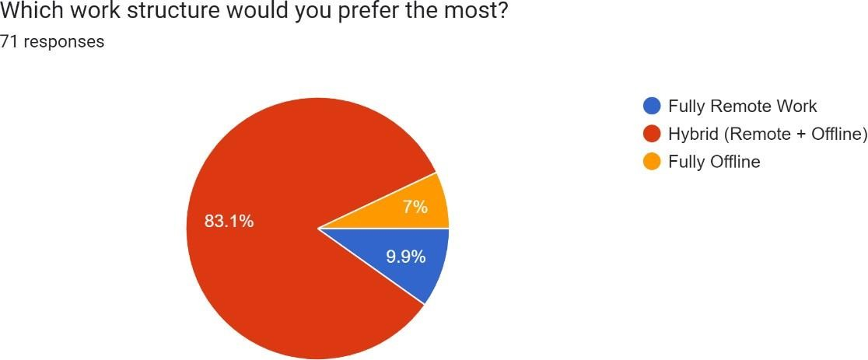

*Fig. 5.1: Pie chart depicting the preferred work structure.*

Majority of the respondents (83.1%) prefer a hybrid work model, blending remote and offline work to achieve flexibility. 18.9% of the respondents favor either fully remote working opportunities or fully offline, of which a higher percentage showed a significant interest in having the option to work outside traditional office settings.

## Effectiveness of Remote Work -

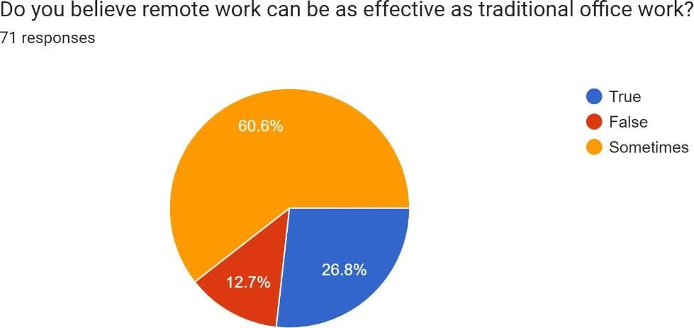

*Fig. 5.2: Pie chart depicting the effectiveness of remote work.*

Opinions vary on the effectiveness of remote work, with 60.6% indicating that it can be effective in certain circumstances only, while only 26.8% affirming that it can be as effective as traditional work. This suggests a nuanced view where remote work's effectiveness may depend on specific job roles or individual work styles.

## Productivity & Work-Life Balance -

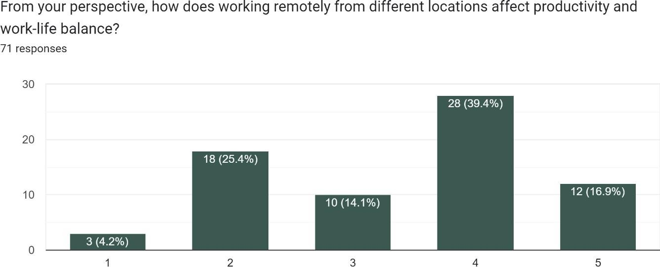

*Fig. 5.3: Bar graph depicting the productivity of work-life balance.*

The average rating for how remote work from various locations impacts productivity and work-life balance is moderate, around 2.5 out of 5. This indicates a mixed impact, with some respondents finding it beneficial and others noting potential challenges in maintaining balance.

## Drawbacks of Working from Different Locations -

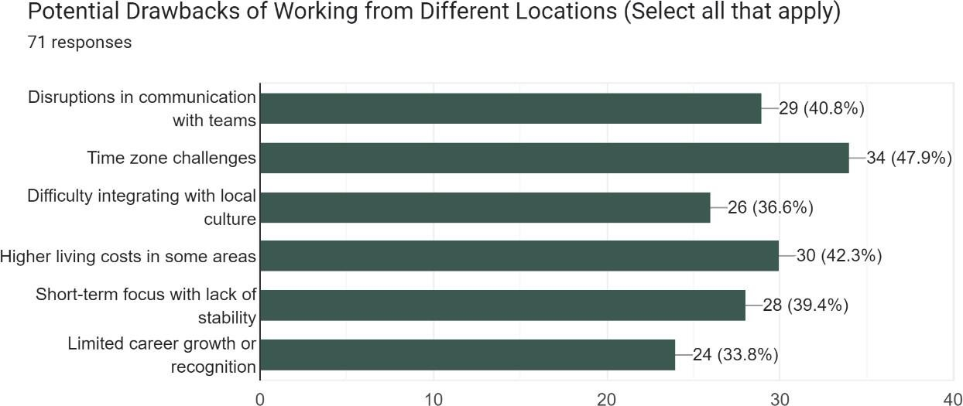

*Fig. 5.4: Bar graph depicting the drawbacks of working from different locations.*

The most frequently reported challenges include **time zone challenges** and **disruptions in communication**. These issues underscore the logistical hurdles that remote workers face when coordinating across regions.

## Concern about Isolation -

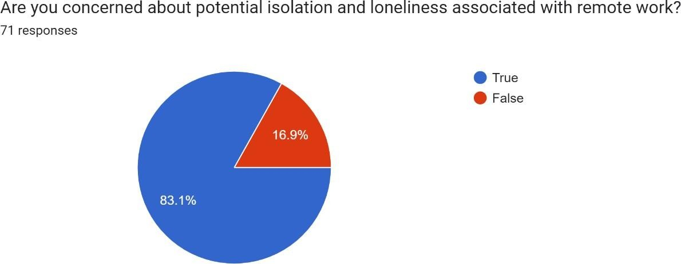

*Fig. 5.5: Pie chart depicting the concern about isolation.*

More than 80% of the respondent’s express concern about isolation and loneliness, indicating a prominent apprehension that remote work can or may lead to reduced social interaction.

## Local Economy Impact -

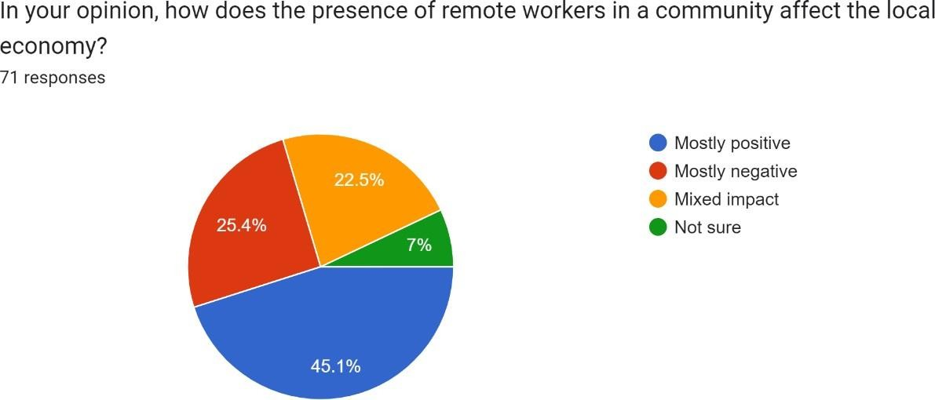

*Fig. 5.6: Pie chart depicting the local economy impact.*

The presence of remote workers in local communities is viewed positively by 45% of respondents, who believe it has a **mostly positive** effect, while 25% note of a **mixed impact**. This suggests that while remote work can boost local economies, some may have reservations about its longer-term effects.

## Factors Influencing Choice of Remote Work -

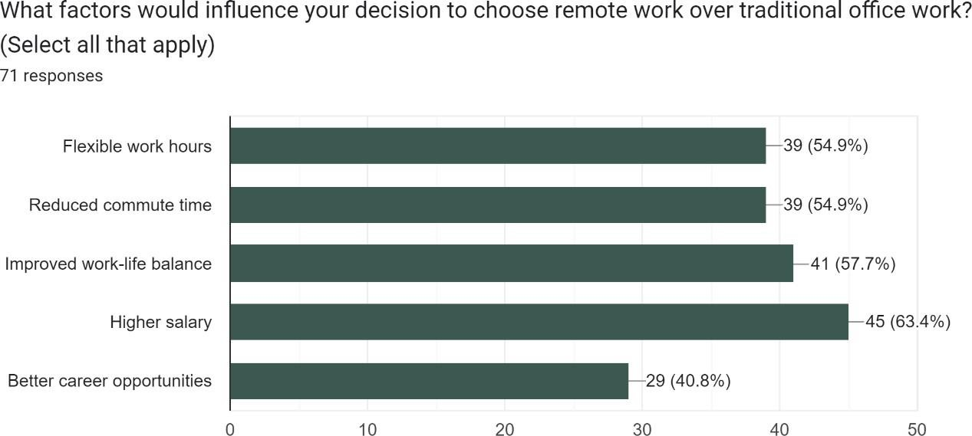

*Fig. 5.7: Bar graph depicting the factors influencing choice of remote work.*

**Flexible hours** and **reduced commute time** are the most popular factors motivating respondents to choose remote work over traditional setups. These insights highlight the value remote workers place on personal time management and lifestyle improvements.

## Impact on Professional Development -

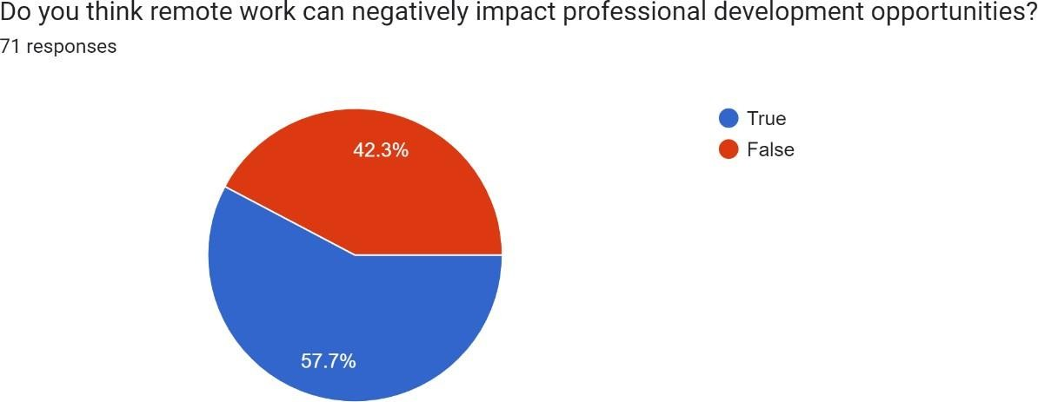

*Fig. 5.8: Pie chart depicting the impact on professional development.*

Majority of the respondents feel that remote work could hinder professional development, pointing to potential concerns around limited networking opportunities and reduced access to mentorship or career growth.

## Impact of Franchises on Local Businesses -

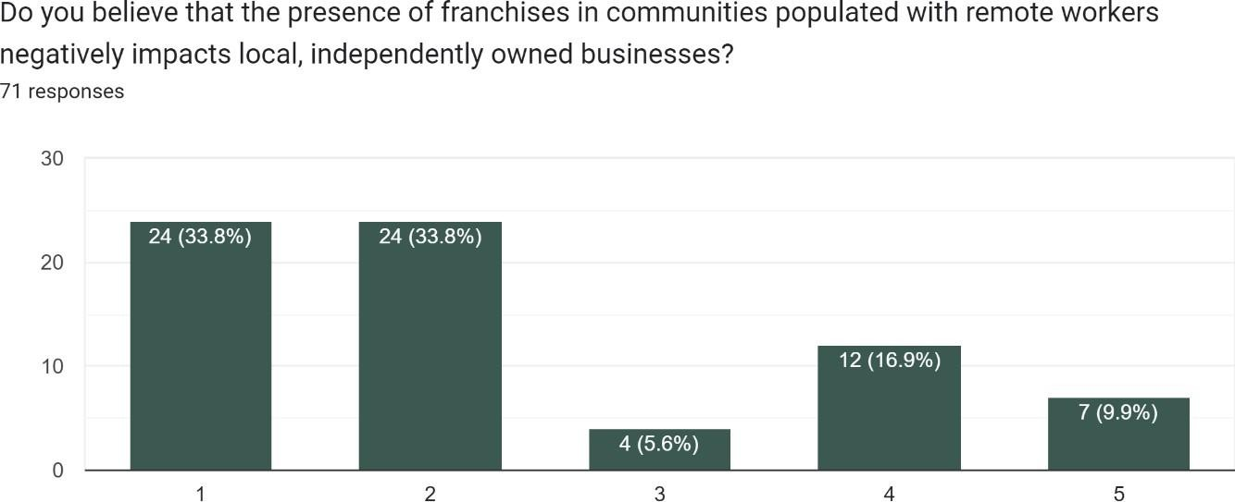

*Fig. 5.9: Bar graph depicting the impact of franchises on local businesses.*

There’s a moderate concern that franchises may harm local businesses, with an average sentiment rating of around 2.5 out of 5. This suggests a split opinion on whether franchise growth in remote-worker-populated areas detracts from locally run shops and businesses.

## Modernization of Developing Cities -

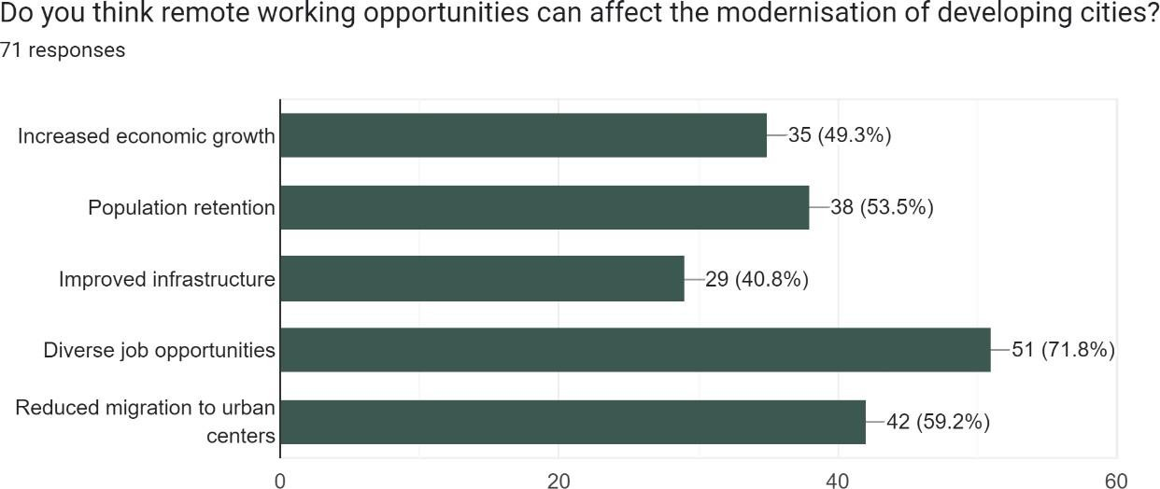

*Fig. 5.10: Bar graph depicting the modernization of developing cities.*

Remote work is largely seen as a positive factor for developing cities, with benefits like **increased economic growth** and **population retention** being highlighted. Respondents believe remote work could encourage urban improvements and infrastructure development.

## Impact of Chains and Tourist Shops -

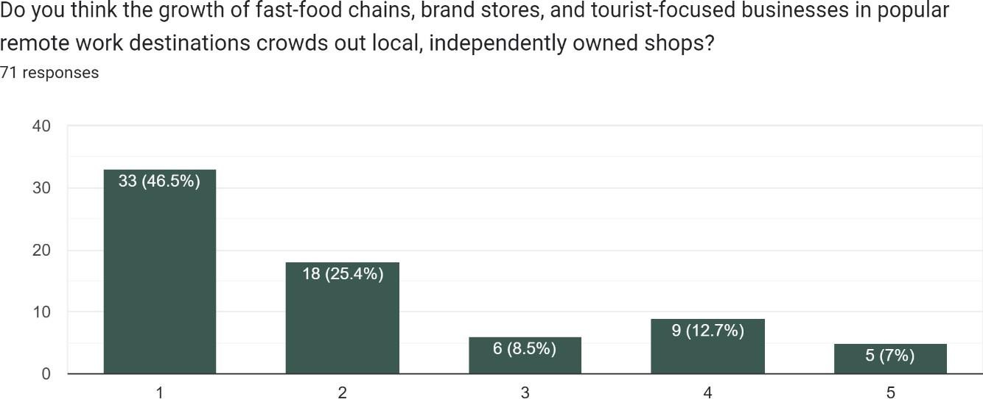

*Fig. 5.11: Bar graph depicting the impact of chains and tourist shops.*

The average sentiment score indicates a concern that the expansion of brand stores and tourist- focused businesses in popular remote work locations may displace local shops, potentially altering the community's uniqueness and economy.

# CONCLUSION

The consensus reveals that digital nomadism offers both promising opportunities and significant challenges. A majority of respondents favour a hybrid work model, indicating a desire for flexibility that allows for both remote and in-person engagement. Remote work is seen as effective, though its success appears to vary by individual circumstances, with many finding it viable but acknowledging that it may not fully replicate the traditional office experience. One of the primary advantages of digital nomadism is its potential to improve work-life balance, though this benefit is moderated by logistical hurdles like time zone coordination and communication disruptions. Additionally, while factors such as flexible hours and reduced commute time make remote work appealing, concerns about professional development suggest that fully remote environments might lack the networking and mentorship opportunities often found in physical workplaces.

Digital nomadism also brings complex social and economic effects on local communities. Many believe that remote workers positively impact local economies, potentially spurring modernization and infrastructure improvements in developing areas. However, there is also concern about the social downsides, as isolation and loneliness are prominent issues among remote workers. Additionally, the expansion of franchises and tourist-oriented businesses in popular remote work destinations is viewed as a potential threat to local, independently owned businesses, which could alter the cultural and economic fabric of these communities. Overall, while digital nomadism supports flexibility and growth, its sustainable integration will require addressing these social and economic challenges to balance its benefits with the well-being of remote workers and local communities.

# RECOMMENDATIONS

To harness the economic and social benefits of digital nomadism while addressing its potential drawbacks, here are some recommendations to implement strategies across key areas such as economic growth, social integration, infrastructure development, and sustainable community impact. These recommendations aim to balance the needs of local communities and digital nomads, fostering an inclusive, thriving environment.

# Promote Balanced Economic Growth and Local Business Support -

* + **Incentivize Local Business Adaptation**: Offer subsidies or grants to help local businesses adapt to digital-friendly environments, such as providing co-working spaces, reliable internet, and digital services.
  + **Tax Incentives for Local Spending**: Provide tax benefits or discounts for digital nomads who support local businesses rather than international chains, encouraging economic contributions that strengthen community-based economies.
  + **Encourage Collaborative Spaces**: Promote partnerships between local entrepreneurs and remote workers through shared workspaces and innovation hubs, facilitating knowledge transfer and economic diversification.

# Mitigate Housing Market Pressure -

* + **Regulate Short-Term Rentals**: Establish policies that cap or regulate short-term rental properties to prevent housing shortages and keep local rental markets affordable.
  + **Promote Affordable Housing Initiatives**: Partner with developers to build or maintain affordable housing for local residents, ensuring that digital nomadism does not exacerbate local housing crises.
  + **Encourage Long-Term Residency**: Offer incentives, such as extended visa programs, for remote workers who commit to long-term stays, which can stabilize housing demand and contribute more meaningfully to the community.

# Facilitate Cultural Exchange and Social Integration -

* + **Create Cultural Exchange Programs**: Develop community-led programs that allow remote workers and residents to engage in cultural and social exchanges, fostering mutual understanding and respect.
  + **Community Events and Workshops**: Organize local events, such as festivals, skill- sharing workshops, and volunteering opportunities, to bridge the social gap between digital nomads and residents.
  + **Foster Inclusive Communication**: Encourage digital nomads to learn about local customs and languages, promoting respect and meaningful engagement with the community.

# Develop Sustainable Infrastructure -

* + **Upgrade Digital Infrastructure**: Invest in high-speed internet and communication networks, prioritizing underserved areas to support both remote workers and local residents’ connectivity needs.
  + **Public Transportation Enhancements**: Improve local transportation options, including accessible, eco-friendly transit solutions that cater to increased demand from digital nomads.
  + **Sustainable Resource Management**: Implement green energy initiatives, waste reduction programs, and resource conservation measures that can support an influx of remote workers while preserving environmental resources.

# Support Responsible Tourism and Community Engagement -

* + **Educational Programs on Local Etiquette**: Educate digital nomads on local customs, sustainability practices, and respectful tourism to minimize disruption to community norms.
  + **Promote Local Experiences Over Tourist Chains**: Highlight locally-run shops, restaurants, and cultural attractions, steering nomads away from international franchises and towards unique, community-centered experiences.
  + **Limit Franchise Expansion in Residential Areas**: Implement zoning policies that prevent franchise saturation in residential and cultural zones to protect local businesses and preserve community identity.

# Monitor and Evaluate Social and Economic Impact -

* + **Establish Data Collection Systems**: Regularly collect data on the economic, social, and environmental impacts of digital nomadism, using surveys and local feedback to understand ongoing needs and concerns.
  + **Implement Periodic Policy Reviews**: Use gathered data to review and adjust policies, ensuring that digital nomad programs remain beneficial to both nomads and local communities.
  + **Engage Community Stakeholders**: Involve local residents, businesses, and policymakers in discussions about digital nomadism’s impact, creating collaborative solutions to shared challenges.

# Encourage Hybrid Work and Professional Development Programs -

* + **Hybrid Workspace Development**: Develop versatile workspaces that support both in- person collaboration and remote flexibility, catering to the hybrid work preferences identified in the report.
  + **Virtual Networking and Mentorship Programs**: Partner with local businesses to create networking and mentorship platforms, helping remote workers stay connected to professional growth opportunities.
  + **Promote Wellness Programs**: Offer wellness resources, mental health support, and community activities for remote workers to address issues of isolation and enhance work-life balance.

# Develop Clear Regulatory Frameworks -

* + **Implement Visa and Permit Guidelines**: Establish clear regulations for digital nomad visas, including guidelines on allowable activities, length of stay, and tax obligations to ensure contributions to the local economy.
  + **Business Operation Standards**: Set regulations for foreign businesses operating locally, ensuring they meet community standards and contribute to local employment where possible.
  + **Establish Accountability Measures**: Hold digital nomads and companies accountable for adhering to local laws, including respecting cultural sites, minimizing environmental impact, and supporting local businesses.

These recommendations aim to guide communities in maximizing the benefits of digital nomadism while minimizing its challenges. A balanced approach will help host locations preserve their unique identity, foster local economic resilience, and ensure that digital nomads contribute positively to the local economy, social fabric, and environment.

# REFERENCES

1. C. Blancas, "Analysis of the economic benefits brought by digital nomads to local businesses such as dining establishments and co-working spaces," 2022.
2. R. Morgan, "Research on the economic diversification achieved through digital nomad hubs and their attraction of international events," 2023.
3. J. Smith, "Discussion on the cultural exchange fostered by digital nomads in urban settings, enriching community dynamics," 2021.
4. A. Jenkins and T. Lee, "Examination of knowledge exchange and the promotion of innovation through interactions between digital nomads and local entrepreneurs," 2023.
5. L. Chen, "Study on the impact of digital nomadism on housing markets, specifically rent increases and gentrification," 2022.
6. M. Martinez, "Exploration of infrastructure challenges faced by host cities as a result of the growing digital nomad population," 2021.
7. P. Brooks, "Analysis of the social integration challenges posed by the transient lifestyle of digital nomads and its effects on community engagement," 2022.
8. S. Hernandez and F. Reyes, "Investigation into cultural displacement issues experienced by local residents due to the presence of digital nomads," 2023.
9. B. Oliver, "Discussion on sustainability concerns related to digital nomadism and the debate over its long-term impacts," 2022.
10. D. Jackson, "Examination of the inequitable distribution of economic benefits among local populations," 2023.
11. M. Thompson and S. Gupta, "Advocacy for research on policy frameworks to manage digital nomadism effectively while protecting local interests," 2023.
12. I. De Los Rios Hernández, "Digital Nomadism: Transnational Economic Relations in the Emerging Economies," *Harvard International Review*, Dec. 30, 2023. [Online]. Available: [https://hir.harvard.edu/digital-nomadism-transnational-economic-relations-in-the-emerging-](https://hir.harvard.edu/digital-nomadism-transnational-economic-relations-in-the-emerging-economies/) [economies/](https://hir.harvard.edu/digital-nomadism-transnational-economic-relations-in-the-emerging-economies/)

# APPENDIX

**Questionnaire:**

# Impact of Digital Nomadism: Challenges and Opportunities

As remote work becomes increasingly popular, communities around the world are experiencing shifts in economic, social, and cultural dynamics. This survey aims to understand public opinions on the impacts of remote work on local communities and economies, including both the opportunities and challenges it may bring.

Your responses will help provide valuable insights into how local businesses, housing markets, infrastructure, and community identity are affected. By participating, you contribute to a better understanding of how remote work trends might shape the future of communities globally.

Thank you for your time and honest responses!

Total Responses - 71 Google Form - [Link](https://docs.google.com/forms/d/e/1FAIpQLScdi8-kb_FFOdtWFQ2W4KkDWgfxM78Pd4H236jN7fJwMywwSg/viewform)

*Indicates Required Question

